Telecom customer churn Analysis

Project Overview
This project analyzes customer churn behaviour using transactional data from 6418 entries. The goal is to uncover insights into churn patterns, customer segments, product preferences, and subscription behaviour to guide strategic business decisions.

Dataset Summary
- Rows: 6418 - Columns: 18 - Key Features:
- Customer demographics (Age, Gender, Location, churn status)

Data Analysis using SQL (Business Transactions)
We performed structured analysis in PostgreSQL to answer key business questions:
- Gender percent :
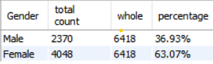

- Customer status percent: – Identified and segregated customers who stayed, churned or new joiners.
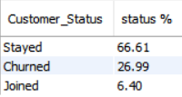

- Customer status percent and revenue percent: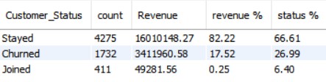

Dashboard in Power BI

Finally, we built an interactive dashboard in Power BI to present insights visually.

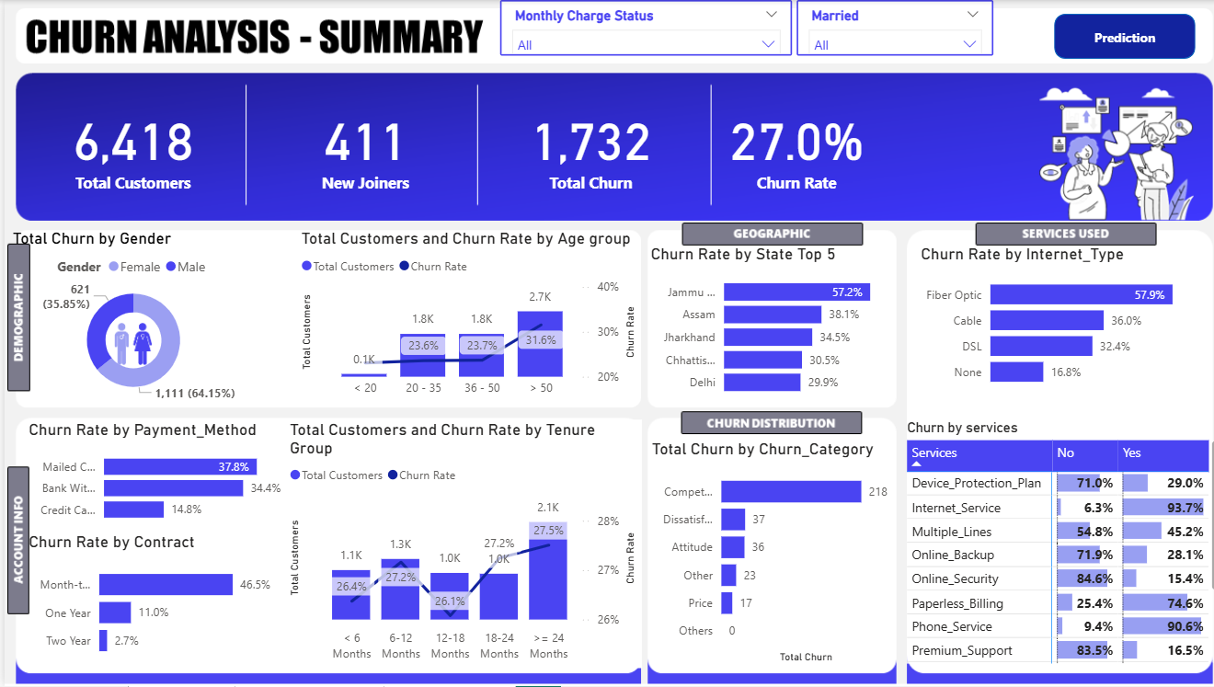

Churn prediction using machine learning on new joiners
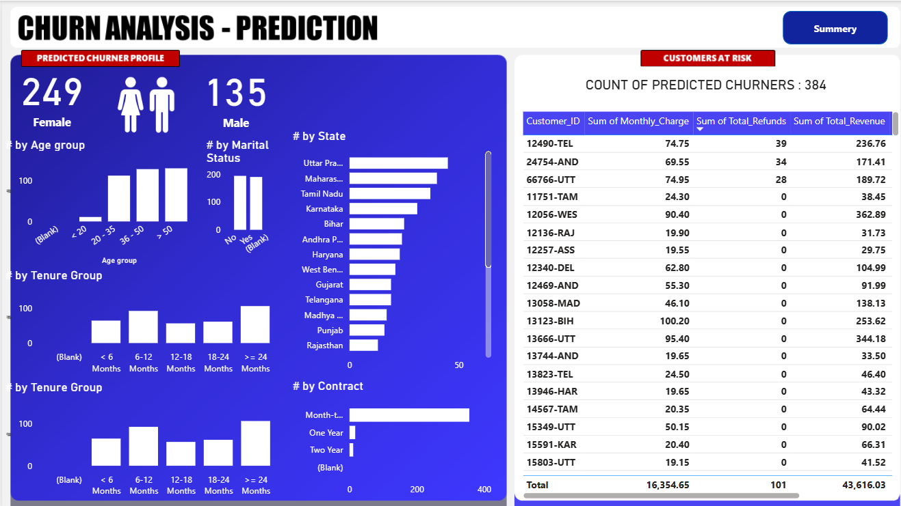

Business Recommendations
- Competitive pricing: From user feedbacks its obvious most of the customers churned because they found better deals from competitors. Have pricing and other deals re-thought.
- Boost yearly contracts: Promote exclusive benefits for yearly contracts.
- Customer Loyalty: Reward customers with consecutive year contracts.
- Address Age group: Majority of customers are above 50 years so are the majority of churners and the support staff attitude towards them also seems to be an issue besides competitors. Train your staff to be friendly to the people of age above 50 if not all of the people.

